**Fabian LeFevre**

**HOMEWORK**

For this assignment, you’ll need to do some Googling. For these questions, please include your references that you used to answer the questions.

1. What exactly is Git and why is it important?

**Git is a version control program that works as a decentralized system. It is important because it makes project and file management easy. It can make it so an older version of a file can be reinstated.**

1. What is the purpose of *tagging*? Look up the command for creating a tag. Add a tag for your current commit on your virtual machine, naming the tag v0.1(remember that you need to be in /home/<username/CSI3660-Lab5 or in a cloned repository). Show me that the tag was successfully created (using the command for *listing* tags, not *creating* tags).

**Tagging’s purpose is to mark points of interest in the git repository’s history. For example, labeling project versions to show current project completion.**

**Commands for tagging:**

**git tag –a v0.1 –m “Made a tag for last Commit Changed the TODO”**

**git tag or git show v0.1 displays what tags have been made or what commit is associated with the passed tag name.**

1. How does Git differ from more standard types of source control (e.g., Subversion)?

**Git is a decentralized version control/tracking program. Rather than clients work on a repository through a connection from their device to the repository, they take the repository to their device and send commits to the main repository. (Github has the main repository, client copies/clones the repo to their system, any changes made on the cloned repo are then pushed to the main when needed)**

1. What is the purpose of branching and merging?

**Branching allows the same git repository to be copied but not moved for someone else to work on or for additional aspects of a project to be worked on while not changing the original/main repository.**

**Merging combines/alters any changes made in other branches to another branch. If one branch is finished, the main branch can merge that branch’s work into its own. Can also do this between two branches that are not the main.**

1. Why is the addition of a *staging area* helpful in Git?

**A staging area is helpful for tracking just the files or folders added with the command “git add”. It makes it so that only those files/folders are important for git to keep track of.**

1. As promised, you will now kickstart your course project if you haven’t started it yet. For this question, you need to demonstrate that you have at least part of your project working on your server. For example, if you were setting up an ownCloud server, you could show me that you installed ownCloud on the system and take a screenshot of it minimally working. Or, if you were running a Minecraft server you could at least show me that you compiled the server and can execute it from the command line.

**INSTALLED THE STEAMCMD command line**

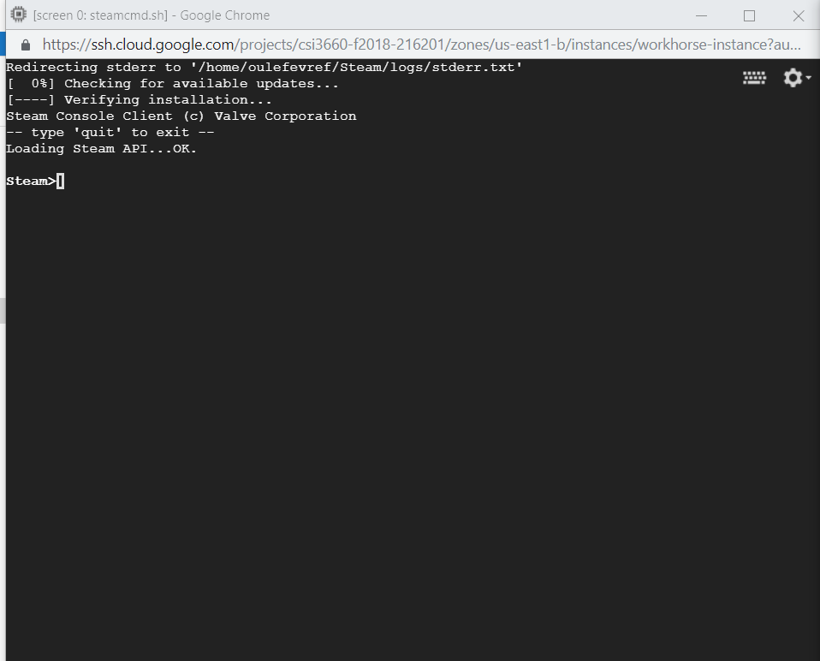

1. **In a short paragraph, discuss what the next step of your project is. Basically, Question (6) made sure that your service is at least started. What is the next step to success?**

**The next step is to install GMOD and all necessary files and directories. (TF2, Half-life, Counter-Strike Source, etc)**

**Then try to run the GMOD server and join it with my personal Steam account. After making sure that http is working and the instance has a external IP address that others can access.**

**____________________________________________________________________________**

**LAB REPORT REQUIREMENTS**

Copy and paste this document into a new document, but remove all text except everything in**red and bold.** For each of those points, put the output that was requested, and discuss any points that were asked about.For instance, if I ask you to ‘show me that a file exists’ then you need to use the appropriate **ls** command to do so.

Make sure you answer the homework questions as well. You can submit it all in one document.